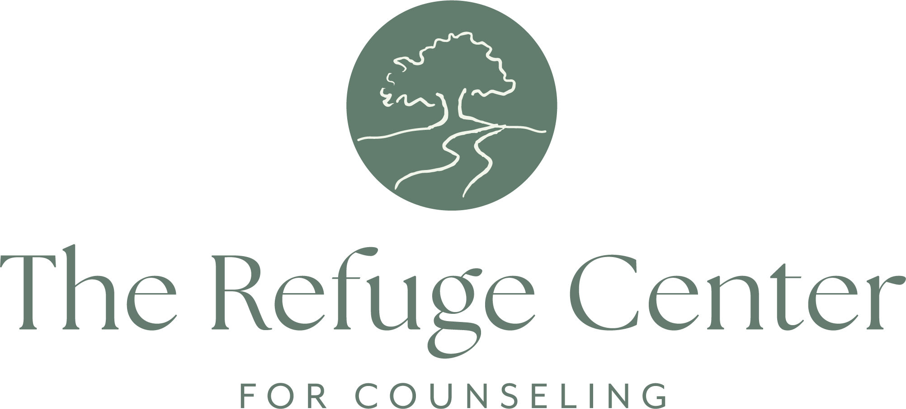

Hospitality Support Associate

Purpose of the Position: The Hospitality Support Associate serves as a welcoming presence for clients, staff, and visitors at The Refuge Center for Counseling. This part-time position supports the overall client experience by providing exceptional hospitality, maintaining inviting and safe common spaces, and assisting with evening facility operations. The Hospitality Support Associate reports directly to the Hospitality Manager.

Primary Responsibilities:
- Greet and welcome clients, visitors, and team members with warmth, professionalism, and compassion.
- Assist clients with the check-in process and answer general questions as needed.
- Maintain clean, organized, and inviting common areas, including straightening furniture, pillows, toys, and other hospitality spaces.
- Conduct routine inspections of the playground and outdoor waiting areas to ensure cleanliness and safety.
- Complete all closing procedures, including:
  - Ensuring all exterior and interior doors are secured.
  - Turning off lights, TVs, lamps, candles, indoor fountain, fireplaces, and other designated equipment.
  - Performing a final walkthrough of the building to verify that all clients and team members have departed safely.
  - Exiting the building with the last team member and ensuring the facility is properly secured.
  - Secure and close the Group Lodge and outdoor gathering areas, including closing all outdoor umbrellas and ensuring all hospitality spaces are properly secured.

Other Duties:
- Other duties may be assigned from time-to-time to drive the mission, vision, and strategy of The Refuge Center for Counseling
- Receive and distribute deliveries.
- Maintain strict confidentiality and discretion in all client, staff, and organizational interactions.
- Perform all duties in a professional manner while demonstrating courtesy, respect, and cooperation toward clients, coworkers, and leadership.
- Attend staff meetings, trainings, and other organizational gatherings as requested.
- Perform other duties as assigned in support of the mission, vision, and strategic objectives of The Refuge Center for Counseling.

Desired Characteristics:
- Warm, welcoming, and approachable demeanor.
- Strong interpersonal skills with a natural ability to make others feel comfortable and valued.
- Excellent listening skills and demonstrated empathy.
- Dependable, proactive, and detail-oriented.
- Ability to work independently and exercise sound judgment.
- Commitment to the mission, vision, and values of The Refuge Center for Counseling.

Job Qualifications/Requirements
- High School Diploma, or equivalent
- Good communication skills
- Microsoft Office proficiency, a plus
- Customer service or hospitality experience preferred

